We have created two Recipe Instruction XML for Toasted and Non-Toasted.



I have also created Three Extn Attributes @ OrderLine level

ExtnToasted these are data type Varchar2 whose value can be “Toasted” or “Non-Toasted”

And ExtnItemType which could be “Hoagies ; Sandwich ; Beverages”

I have implemented BeforeCreateOrder UE to read from Instruction from a service which read from the file depending upon the ExtnToasted Value.

And Return the instruction file for Order line.

We are stamping “Instruction Text” for Instruction Tag for Instruction Type =”Recipe Instruction “

I created Order with below XML

<Order DocumentType="0001" AllocationRuleID="SYSTEM" DoNotConsolidate="N" EnterpriseCode="WAWA_Sales" SellerOrganizationCode="WAWA_Sales" BypassPricing="Y" CancelOrderOnBackorder="N" OrderType="REG" EnteredBy="" SCAC="" CarrierServiceCode="" OrderNo="">

<OrderLines>

<OrderLine OrderedQty="2" DeliveryMethod="SHP" ProductClass="" FulfillmentType="SHP" LineType="REG" PrimeLineNo="1" GiftFlag="N" ShipNode="">

<Extn ExtnToasted="Toasted" ExtnItemType="Sandwich" />

<Item ItemID="10000825" UnitOfMeasure="EACH" ItemDesc="Multigrain Sandwich"/>

<LinePriceInfo UnitPrice="25.00" IsPriceLocked="Y" DiscountPercentage="" />

</OrderLine>

<OrderLine OrderedQty="2" DeliveryMethod="SHP" ProductClass="" FulfillmentType="SHP" LineType="REG" PrimeLineNo="2" GiftFlag="N" ShipNode="">

<Extn ExtnToasted="Non-Toasted" ExtnItemType="Sandwich" ExtnChilled="N"/>

<Item ItemID="10000825" UnitOfMeasure="EACH" ItemDesc="Multigrain Sandwich"/>

<LinePriceInfo UnitPrice="25.00" IsPriceLocked="Y" DiscountPercentage="" />

</OrderLine>

</OrderLines>

<PersonInfoBillTo AddressLine1="104 Matthew Ln" AddressLine2="" City="Gilbertsville" State="PA" Country="US" ZipCode="19525" DayPhone="5656789098" EMailID="saxena.v@hcl.com" />

<PersonInfoShipTo FirstName="Vijay" LastName="Saxena" AddressLine1="104 Matthew Ln" AddressLine2="" AddressLine5="" AddressLine6="" City="Gilbertsville" State="PA" Country="US" ZipCode="19525" />

<PriceInfo Currency="USD" />

</Order>

Below is order created with Instruction @order Line

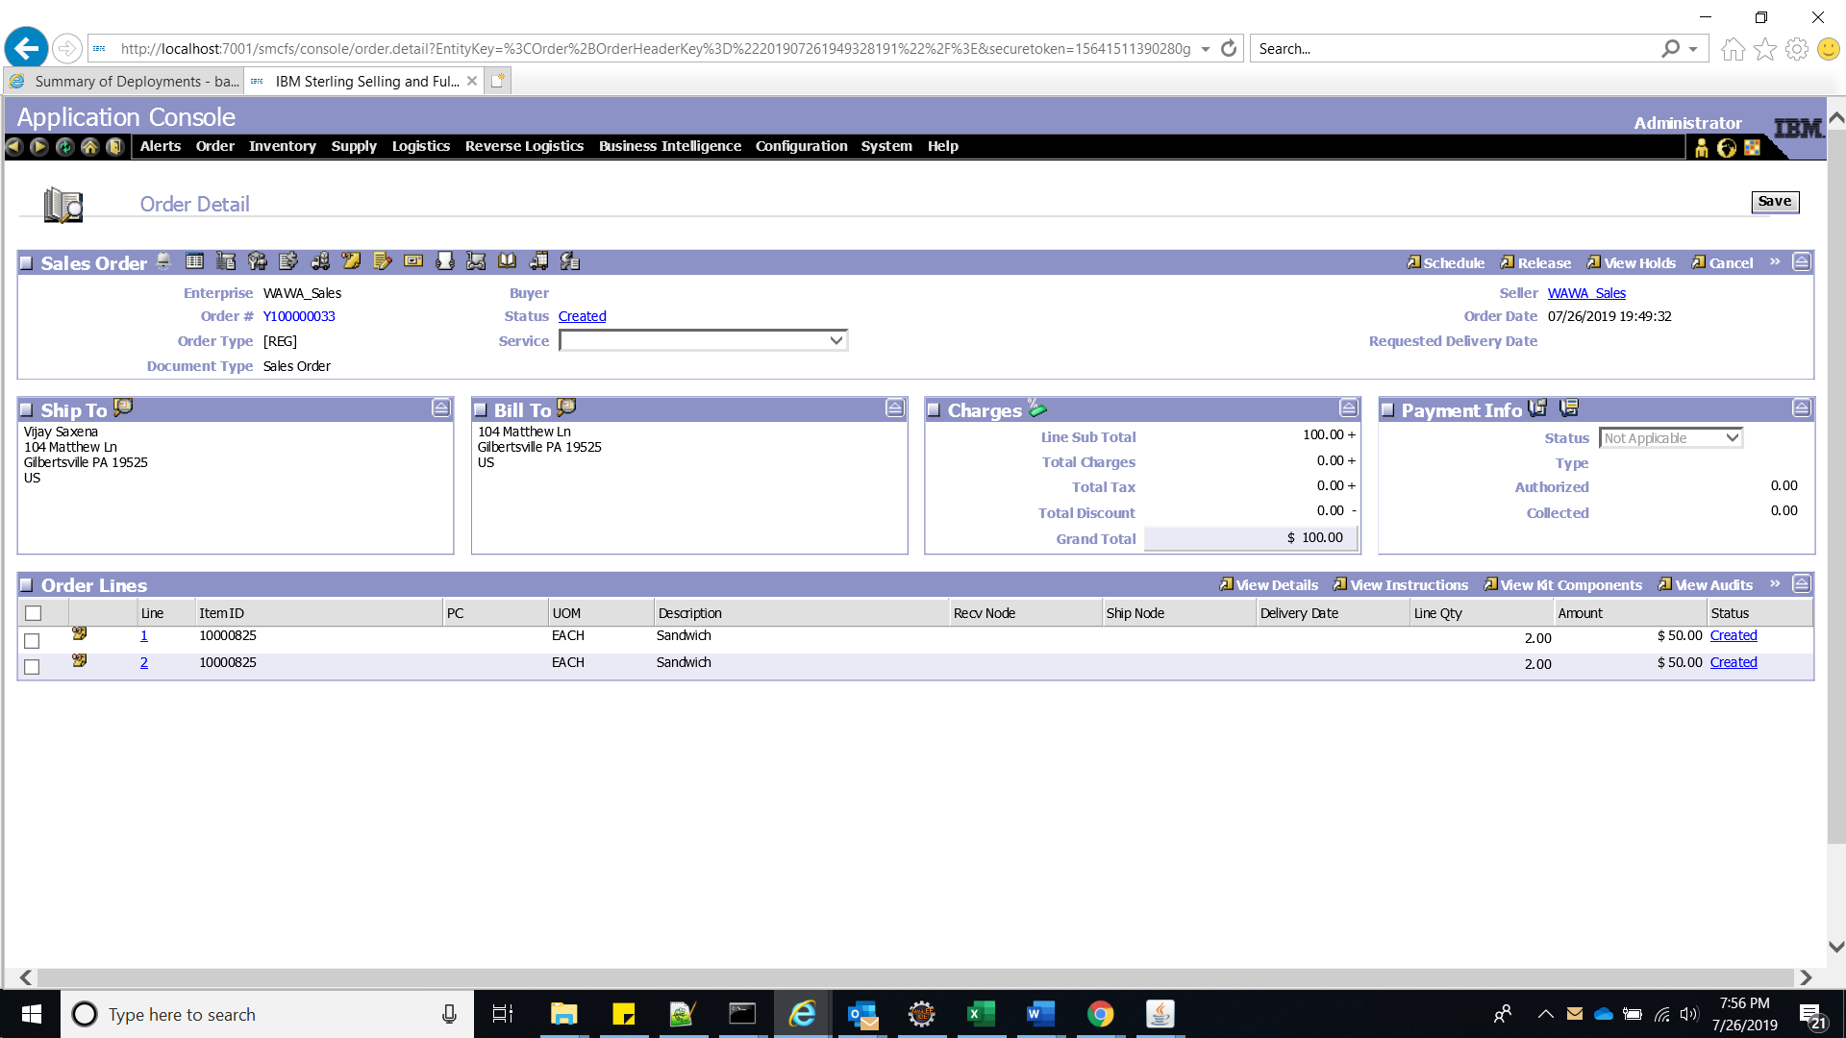

For Order Line -1 we passed Toasted

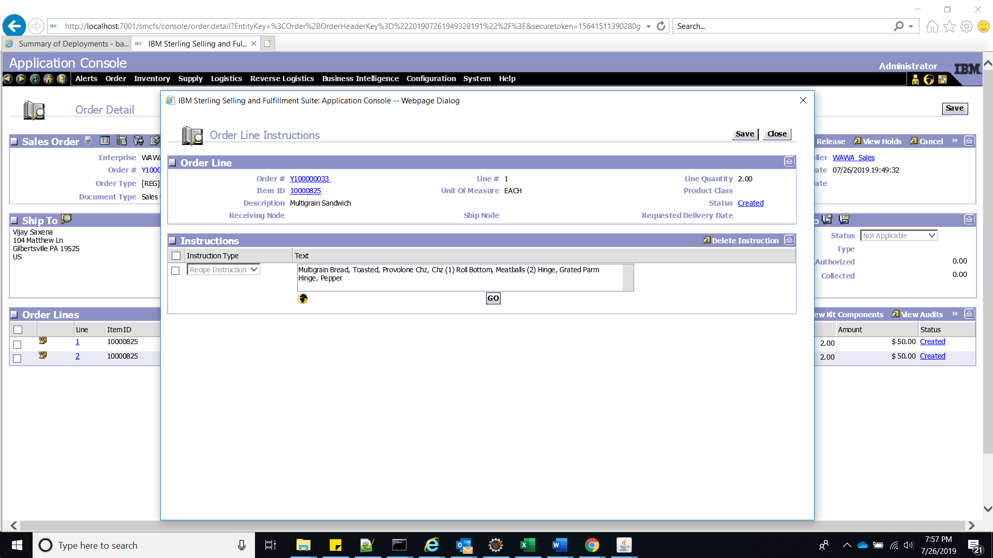

For Order Line -2 we passed Non-Toasted

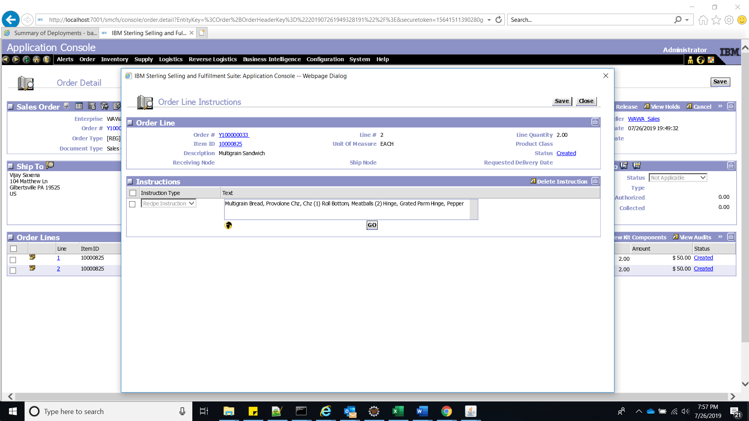

The Order details for same order is as below

<Order Action="CREATE" AllocationRuleID="SYSTEM" BypassPricing="Y"

CancelOrderOnBackorder="N" CarrierServiceCode=""

DoNotConsolidate="N" DocumentType="0001" EnteredBy=""

EnterpriseCode="WAWA_Sales" OrderNo="" OrderType="REG" SCAC="" SellerOrganizationCode="WAWA_Sales">

<OrderLines>

<OrderLine DeliveryMethod="SHP" FulfillmentType="SHP"

GiftFlag="N" LineType="REG" OrderedQty="2" PrimeLineNo="1"

ProductClass="" ShipNode="">

<Extn ExtnItemType="Sandwich" ExtnToasted="Toasted"/>

<Item ItemDesc="Multigrain Sandwich" ItemID="10000825" UnitOfMeasure="EACH"/>

<LinePriceInfo DiscountPercentage="" IsPriceLocked="Y" UnitPrice="25.00"/>

<Instructions>

<Instruction

InstructionText="Multigrain Bread, Toasted, Provolone Chz, Chz (1) Roll Bottom, Meatballs (2) Hinge, Grated Parm Hinge, Pepper" InstructionType="REC_INS"/>

</Instructions>

</OrderLine>

<OrderLine DeliveryMethod="SHP" FulfillmentType="SHP"

GiftFlag="N" LineType="REG" OrderedQty="2" PrimeLineNo="2"

ProductClass="" ShipNode="">

<Extn ExtnChilled="N" ExtnItemType="Sandwich" ExtnToasted="Non-Toasted"/>

<Item ItemDesc="Multigrain Sandwich" ItemID="10000825" UnitOfMeasure="EACH"/>

<LinePriceInfo DiscountPercentage="" IsPriceLocked="Y" UnitPrice="25.00"/>

<Instructions>

<Instruction

InstructionText="Multigrain Bread, Provolone Chz, Chz (1) Roll Bottom, Meatballs (2) Hinge, Grated Parm Hinge, Pepper" InstructionType="REC_INS"/>

</Instructions>

</OrderLine>

</OrderLines>

<PersonInfoBillTo AddressLine1="104 Matthew Ln" AddressLine2=""

City="Gilbertsville" Country="US" DayPhone="5656789098"

EMailID="saxena.v@hcl.com" State="PA" ZipCode="19525"/>

<PersonInfoShipTo AddressLine1="104 Matthew Ln" AddressLine2=""

AddressLine5="" AddressLine6="" City="Gilbertsville"

Country="US" FirstName="Vijay" LastName="Saxena" State="PA" ZipCode="19525"/>

<PriceInfo Currency="USD"/>

</Order>